**Assignment No: 03**

**University Database Management System**

**By**

**Sachin Gunjal**

**Introduction**

The **University Database Management System (UDBMS)** is an SQL-based project that aims to create a structured and relational database to efficiently manage university-related data.

The system includes multiple interconnected entities such as colleges, departments, professors, and students. By implementing appropriate constraints like **Primary Key**, **Foreign Key**, and **NOT NULL**, this project ensures data accuracy, uniqueness, and consistency across tables. It serves as a foundational project for understanding relational databases and SQL operations in real-world education systems.

**ER Diagram**

**ER Diagram Explanation**

Refer to the ER diagram provided in the image:

* **College_Table**
  + College_ID (PK)
  + College_Name (NOT NULL)
  + College_Area (NOT NULL)
* **Department_Table**
  + Dept_ID (PK)
  + Dept_Name (NOT NULL)
  + Dept_Facility (NOT NULL)
  + **Foreign Key** linked to College_ID (not shown in the table but mentioned to be added)
* **Professor_Table**
  + Professor_ID (PK)
  + Professor_Name
  + Professor_Subject
  + (Could link to Department_ID optionally for normalization)
* **Student_Table**
  + Student_ID (PK)
  + Student_Name
  + Student_Stream
  + **Foreign Key** linked to Department_ID (implied by arrow from department)

**Key Constraints Applied:**

* Primary keys on ID columns ensure uniqueness.
* NOT NULL on important fields like names and facility info.
* Foreign Keys link dependent tables (e.g., Students → Departments, Departments → Colleges).

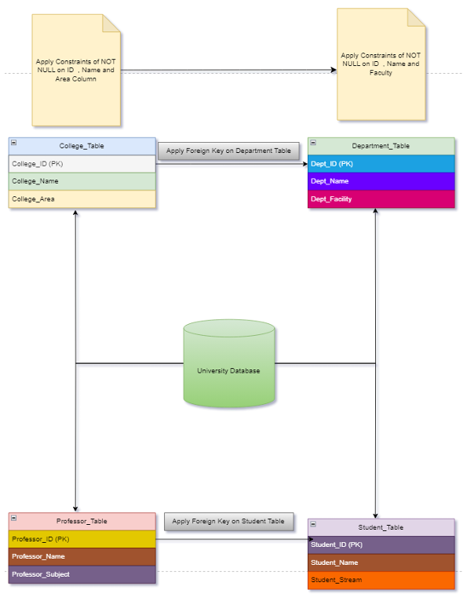

1. **CREATE DATABASE**

We have created university database for this project to add tables to maintain data integrity and organizing and structuring data in a specific way to enhance its readability and usability.

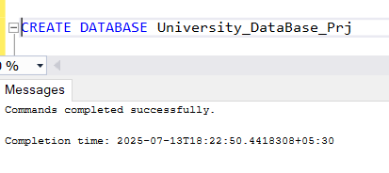

1. **CREATE AND INSERT DATA INTO TABLES**
2. **College_Table**

* College_ID(PK)
* College_Name
* College_Area

CREATE TABLE College_Table(

College_ID INT PRIMARY KEY NOT NULL,

College_Name VARCHAR(100) NOT NULL,

College_Area VARCHAR(100) NOT NULL

);

INSERT INTO College_Table (College_ID, College_Name, College_Area) VALUES

(1, 'Sunrise Institute', 'Pune'),

(2, 'Global Tech University', 'Mumbai'),

(3, 'Skyline College', 'Delhi'),

(4, 'Greenfield University', 'Bangalore'),

(5, 'Northern Heights College', 'Chennai'),

(6, 'Central State University', 'Hyderabad'),

(7, 'Western Valley Institute', 'Jaipur'),

(8, 'Southern Star College', 'Kolkata'),

(9, 'Innovation Hub College', 'Ahmedabad'),

(10, 'Modern Knowledge University', 'Nagpur');

**SELECT * FROM College_Table**

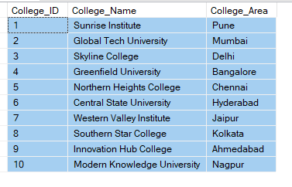

1. **Department_Table**

* Dept_ID(PK)
* Dept_Name
* Dept_Facility

**Foreign key on Department key from College_table**

CREATE TABLE Department_Table(

Dept_ID INT PRIMARY KEY NOT NULL,

Dept_Name VARCHAR(100) NOT NULL,

Dept_Facility VARCHAR(100) NOT NULL,

College_ID INT,

FOREIGN KEY (College_ID) REFERENCES College_Table(College_ID)

);

INSERT INTO Department_Table (Dept_ID, Dept_Name, Dept_Facility, College_ID) VALUES

(101, 'Computer Science', 'AI Lab', 1),

(102, 'Mechanical', 'Robotics Lab', 2),

(103, 'Electronics', 'Circuit Design Lab', 3),

(104, 'Civil Engineering', 'Structure Lab', 4),

(105, 'Electrical', 'Power Systems Lab', 5),

(106, 'Information Tech', 'Coding Hub', 6),

(107, 'Pharmacy', 'Chemistry Lab', 7),

(108, 'Architecture', 'Design Studio', 8),

(109, 'Management', 'Conference Rooms', 9),

(110, 'Physics', 'Research Lab', 10);

**SELECT * FROM Department_Table**

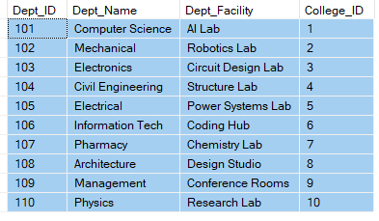

1. **Professor_Table**

* Professor_ID(PK)
* Professor_Name
* Professor_Subject

CREATE TABLE Professor_Table(

Professor_ID INT PRIMARY KEY NOT NULL,

Professor_Name VARCHAR(100),

Professor_Subject VARCHAR(100)

);

INSERT INTO Professor_Table (Professor_ID, Professor_Name, Professor_Subject) VALUES

(201, 'Dr. Neha Sharma', 'Data Structures'),

(202, 'Dr. Ravi Patil', 'Thermodynamics'),

(203, 'Dr. Ayesha Khan', 'Digital Circuits'),

(204, 'Dr. Karan Mehta', 'Concrete Tech'),

(205, 'Dr. Meena Desai', 'Electrical Machines'),

(206, 'Dr. Sandeep Roy', 'Database Systems'),

(207, 'Dr. Pooja Nair', 'Pharmacology'),

(208, 'Dr. Harshit Joshi', 'Urban Design'),

(209, 'Dr. Jyoti Singh', 'Marketing Strategy'),

(210, 'Dr. Anand Rathi', 'Quantum Physics');

**SELECT * FROM Professor_Table**

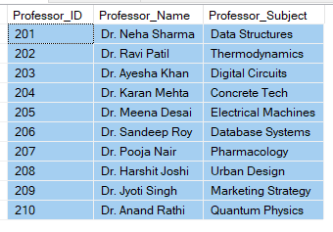

1. **Student_Table**

* Student_ID(PK)
* Student_Name
* Student_Stream

**Foreign Key on Student_Table from Professor_Table**

CREATE TABLE Student_Table(

Student_ID INT PRIMARY KEY NOT NULL,

Student_Name VARCHAR(100),

Student_Stream VARCHAR(100),

Professor_ID INT,

FOREIGN KEY (Professor_ID) REFERENCES Professor_Table(Professor_ID)

);

INSERT INTO Student_Table (Student_ID, Student_Name, Student_Stream, Professor_ID) VALUES

(301, 'Amit Rawat', 'B.Tech CS', 201),

(302, 'Sneha More', 'B.Tech ME', 202),

(303, 'Ravi Thakur', 'B.Tech EC', 203),

(304, 'Komal Jadhav', 'B.Tech CE', 204),

(305, 'Farhan Shaikh', 'B.Tech EE', 205),

(306, 'Anjali Reddy', 'B.Tech IT', 206),

(307, 'Nikhil Shelar', 'B.Pharm', 207),

(308, 'Riya Sen', 'B.Arch', 208),

(309, 'Suresh Dey', 'MBA', 209),

(310, 'Kavita Pillai', 'B.Sc Physics', 210);

SELECT * FROM STUDENT_TABLE

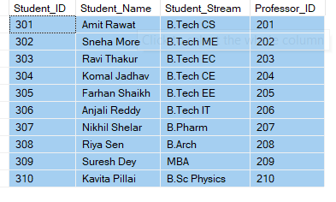

We created a relational structure where each student is associated directly with a professor. This establishes a one-to-many relationship, where one professor can be linked to multiple students. By connecting students to professors instead of departments, we focused on the mentorship or academic supervision aspect, which simplifies the relationship and helps track which professor is responsible for which student. This setup ensures clear academic mapping within the database.

1. **Task**

**1.Give the information of College_ID and College_name from College_Table**

SELECT College_ID, College_Name FROM College_Table

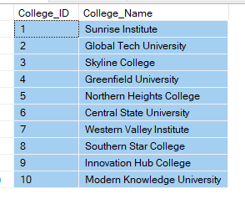

**2. Show Top 5 rows from Student table.**

SELECT TOP 5 * FROM STUDENT_TABLE

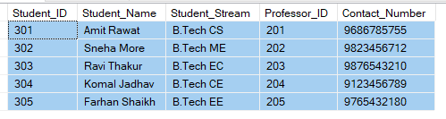

**3. What is the name of professor whose ID is 5**

SELECT * FROM Professor_Table

WHERE Professor_ID = 205

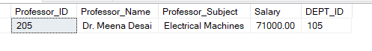

1. **Convert the name of the Professor into Upper case**

SELECT UPPER(Professor_Name) as Capitalized_Prof_Name FROM Professor_Table

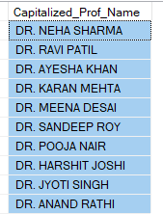

1. **Show me the names of those students whose name is start with a**

SELECT * FROM STUDENT_TABLE

WHERE Student_Name LIKE 'A%'

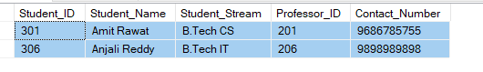

**6. Give the name of those colleges whose end with a**

SELECT * FROM College_Table

WHERE College_Name LIKE '%a'

**NO College name start with A**

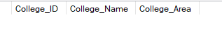

1. **Add one Salary Column in Professor_Table**

ALTER TABLE Professor_Table

ADD Salary DECIMAL(10,2);

UPDATE Professor_Table SET SALARY = 75000 WHERE Professor_ID = 201;

UPDATE Professor_Table SET SALARY = 72000 WHERE Professor_ID = 202;

UPDATE Professor_Table SET SALARY = 70000 WHERE Professor_ID = 203;

UPDATE Professor_Table SET SALARY = 73000 WHERE Professor_ID = 204;

UPDATE Professor_Table SET SALARY = 71000 WHERE Professor_ID = 205;

UPDATE Professor_Table SET SALARY = 76000 WHERE Professor_ID = 206;

UPDATE Professor_Table SET SALARY = 69000 WHERE Professor_ID = 207;

UPDATE Professor_Table SET SALARY = 74000 WHERE Professor_ID = 208;

UPDATE Professor_Table SET SALARY = 72000 WHERE Professor_ID = 209;

UPDATE Professor_Table SET SALARY = 77000 WHERE Professor_ID = 210;

SELECT * FROM Professor_Table

Added NULL values in it next queries

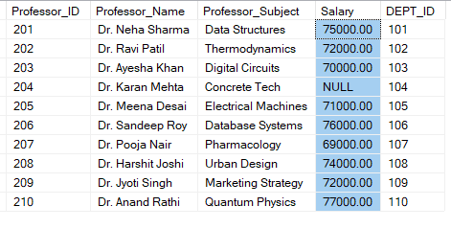

**8. Add one Contact Column in Student_table**

ALTER TABLE STUDENT_TABLE

ADD Contact_Number INT

ALTER TABLE STUDENT_TABLE

ALTER COLUMN CONTACT_NUMBER BIGINT

UPDATE Student_Table SET Contact_Number = 9686785755 WHERE Student_ID = 301;

UPDATE Student_Table SET Contact_Number = 9823456712 WHERE Student_ID = 302;

UPDATE Student_Table SET Contact_Number = 9876543210 WHERE Student_ID = 303;

UPDATE Student_Table SET Contact_Number = 9123456789 WHERE Student_ID = 304;

UPDATE Student_Table SET Contact_Number = 9765432180 WHERE Student_ID = 305;

UPDATE Student_Table SET Contact_Number = 9898989898 WHERE Student_ID = 306;

UPDATE Student_Table SET Contact_Number = 9345678901 WHERE Student_ID = 307;

UPDATE Student_Table SET Contact_Number = 9786453210 WHERE Student_ID = 308;

UPDATE Student_Table SET Contact_Number = 9234567890 WHERE Student_ID = 309;

UPDATE Student_Table SET Contact_Number = 9001234567 WHERE Student_ID = 310;

SELECT * FROM Student_Table

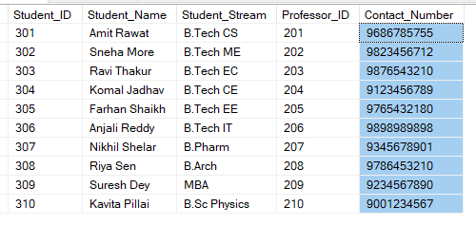

**9. Find the total Salary of Professor**

SELECT * FROM Professor_Table

SELECT SUM(SALARY) AS Total_Professor_Salary

FROM Professor_Table



**10. Change datatype of any one column of any one Table**

ALTER TABLE PROFESSOR_TABLE

ALTER COLUMN SALARY VARCHAR(50);

SELECT COLUMN_NAME, DATA_TYPE

FROM INFORMATION_SCHEMA.COLUMNS

WHERE TABLE_NAME = 'Professor_Table';

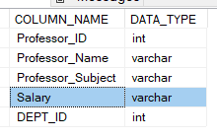

**4.Task 3**

**1. Show first 5 records from Students table and Professor table Combine**

SELECT TOP 5 ST.Student_ID, ST.Student_Name, ST.Student_Stream, ST.CONTACT_NUMBER,

PT.Professor_ID, PT.Professor_Name, PT.Professor_Subject, PT.SALARY

FROM Student_Table ST

INNER JOIN

Professor_Table PT

ON

ST.Professor_ID = PT.Professor_ID

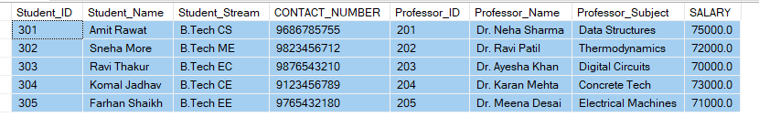

**2. Apply Inner join on all 4 tables together(Syntax is mandatory)**

**-CREATED Column in Professor_table**

ALTER TABLE PROFESSOR_TABLE

ADD DEPT_ID INT

**-Converted column in foreign kry**

ALTER TABLE Professor_Table

ADD CONSTRAINT FK_Professor_Department

FOREIGN KEY (Dept_ID)

REFERENCES Department_Table(Dept_ID);

**-Added values in column**

UPDATE Professor_Table SET Dept_ID = 101 WHERE Professor_ID = 201;

UPDATE Professor_Table SET Dept_ID = 102 WHERE Professor_ID = 202;

UPDATE Professor_Table SET Dept_ID = 103 WHERE Professor_ID = 203;

UPDATE Professor_Table SET Dept_ID = 104 WHERE Professor_ID = 204;

UPDATE Professor_Table SET Dept_ID = 105 WHERE Professor_ID = 205;

UPDATE Professor_Table SET Dept_ID = 106 WHERE Professor_ID = 206;

UPDATE Professor_Table SET Dept_ID = 107 WHERE Professor_ID = 207;

UPDATE Professor_Table SET Dept_ID = 108 WHERE Professor_ID = 208;

UPDATE Professor_Table SET Dept_ID = 109 WHERE Professor_ID = 209;

UPDATE Professor_Table SET Dept_ID = 110 WHERE Professor_ID = 210;

SELECT CT.College_Name, DT.Dept_Name, ST.Student_Name, PT.Professor_Name

FROM College_Table CT

INNER JOIN

Department_Table DT

ON CT.College_ID = DT.College_ID

INNER JOIN

Professor_Table PT

ON DT.Dept_ID = PT.Dept_ID

INNER JOIN

Student_Table ST

ON ST.Professor_ID = PT.Professor_ID;

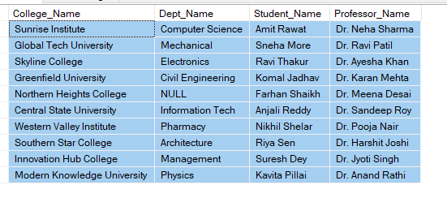

**3. Show Some null values from Department table and Professor table.**

**Added some NULL values inside columns**

UPDATE Department_Table

SET Dept_Name = 'NULL'

WHERE Dept_ID = 105;

UPDATE Professor_Table

SET Salary = 'NULL'

WHERE Professor_ID = 204;

SELECT DT.Dept_Name, PT.Salary FROM DEPARTMENT_TABLE DT

LEFT JOIN

Professor_Table PT

ON

DT.Dept_ID = PT.DEPT_ID

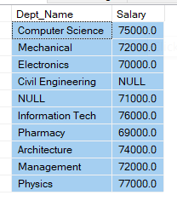

**4. Create a View from College Table and give those records whose college name starts with C**

CREATE VIEW CollegeNamesWith_C

AS

SELECT * FROM College_Table

WHERE College_Name LIKE 'C%'

SELECT College_Name FROM CollegeNamesWith_C

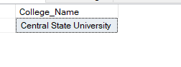

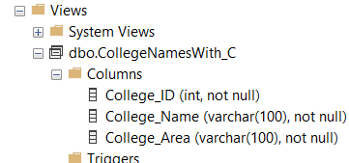

**5. Create Stored Procedure of Professor table whatever customer ID will be given by user it should show whole records of it.**

CREATE PROCEDURE Find_Details

@Cust_id INT

AS

BEGIN

SELECT * FROM Professor_Table

WHERE Professor_ID = @CUST_ID;

END

EXEC Find_Details 207

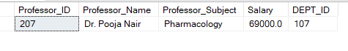

**6. Rename the College_Table to College_Tables_Data .**

EXEC sp_rename 'COLLEGE_TABLE', 'COLLEGE_TABLES_DATA';

SELECT * FROM College_Tables_data

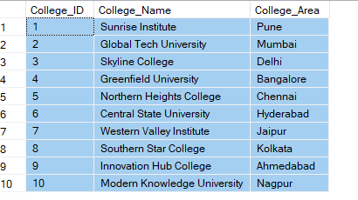

**5. Conclusion**

The University DBMS project successfully demonstrated how to design and manage a structured relational database using SQL. By creating and linking four core tables—College, Department, Professor, and Student—we built a system that models real-world academic data relationships.

Through this project, we implemented foreign keys, handled null values, performed joins, used stored procedures, and modified schemas using **ALTER**, **UPDATE**, and **CAST** commands. We also encountered and resolved common SQL errors like datatype mismatches and arithmetic overflows, which strengthened understanding of data integrity and error handling.

In conclusion, this project provided hands-on experience in building a scalable and normalized database structure, enhanced query-writing skills, and developed a practical understanding of how relational databases operate in educational institutions or similar domains. It lays a solid foundation for working on larger-scale data analytics, reporting, or software applications.